
Cloud computing
Outcome 2 logbook


By AARON CAIRNS

Assignment
I have been tasked to create a simple network infrastructure containing 2 virtual machines with only 1 machine being internet accessible. This is my log book on how I achieved this.
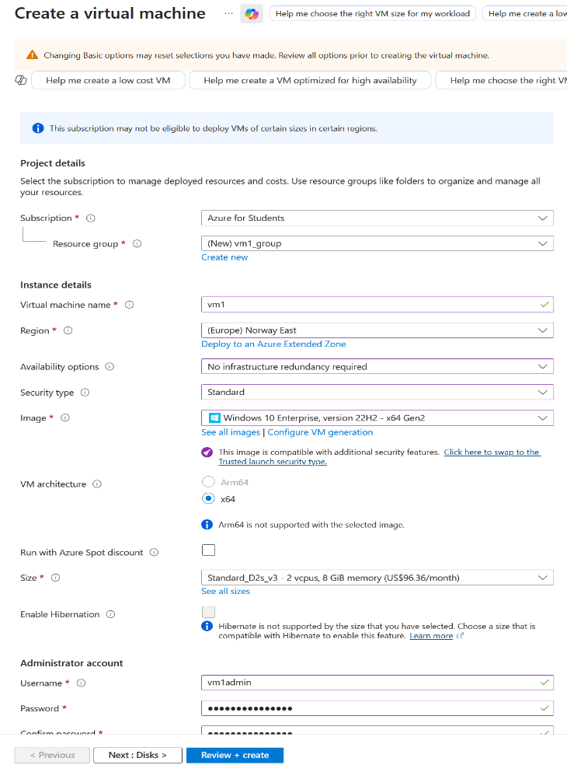

STEP 1: CREATE VM1

Using Microsoft Azures VM builder I began
Making VM1. I made sure to name it “vm1”
And in doing this, a resource group was
Created called “vm1.group”. I also made
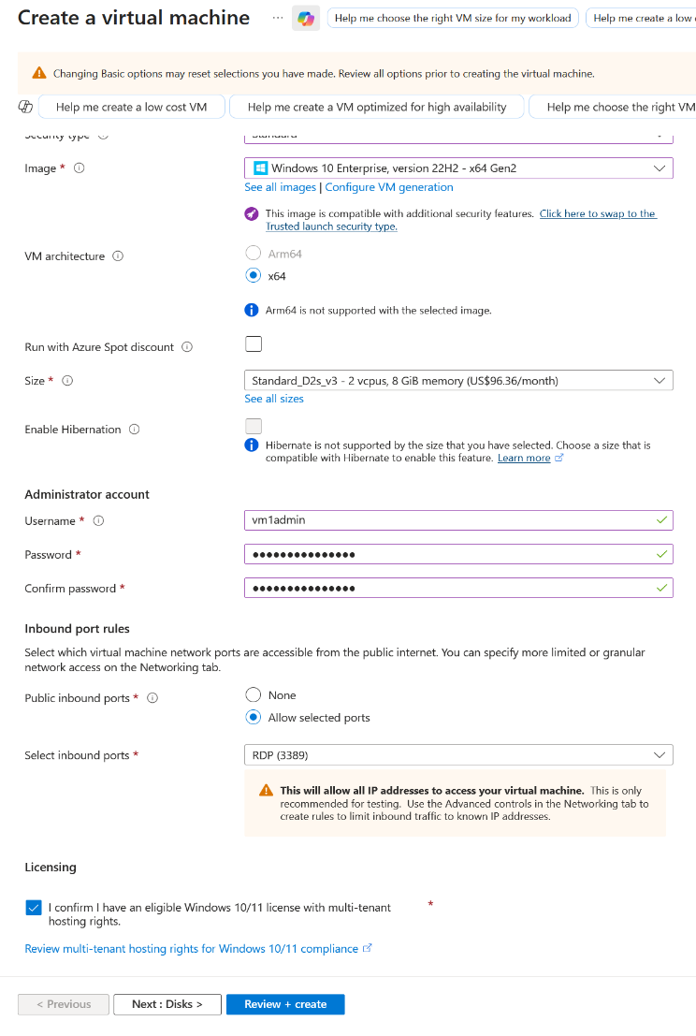
My region Norway east as it is the first region
I selected that never gave me any issues.

I selected “no infrastructure” under
Availability options and “Standard” for the
Security drop down menu and using the
Windows 10 enterprise image for my VM.

I left every other option as the default option.
For the admin account I set my username to
“vm1admin” and my password as
“Virtualmachine1”. I made sure that inbound port
Rules was enabled and set onto RDP (3389).

Once I done this, I clicked the licensing check box
And clicked review and create and once it showed review page I clicked “create” again.

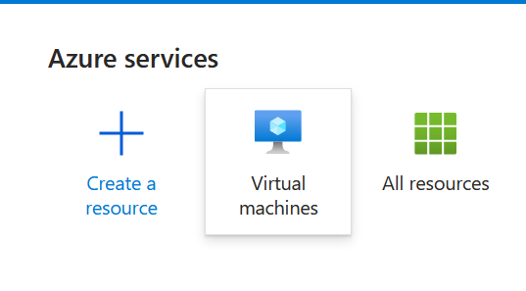
STEP 2: VM1 via RDP

To connect to vm1 via RDP I had to navigate
To the azure home page and find the VM tab.
Then I found the VM I just created and clicked

On it to show all the details of the VM

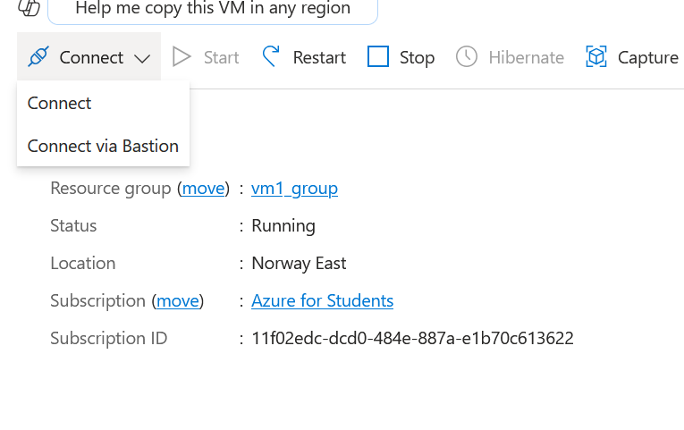

From here I pressed the drop-down menu
Saying “connect” and then clicked connect
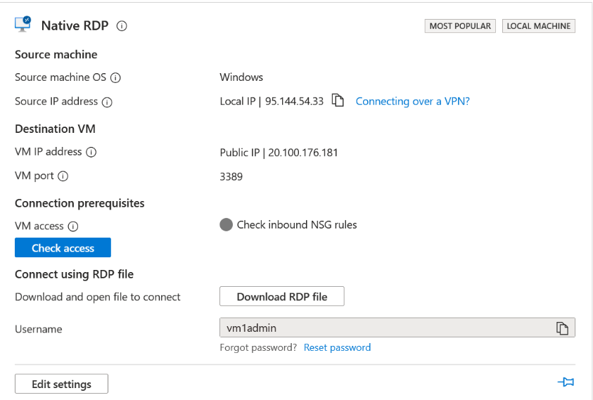

I was then shown a menu containing a
Download RDP file. I select download to get
My VM1 via RDP.

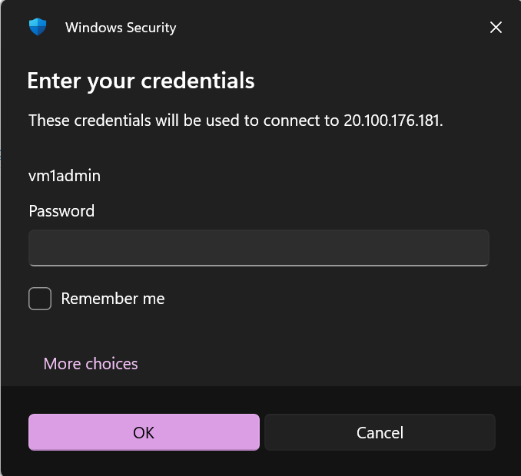

I then open the download file to access
My VM1 and it asked me for my credentials
Before I could open this. I used the username
And password I used earlier to finally access
VM1.

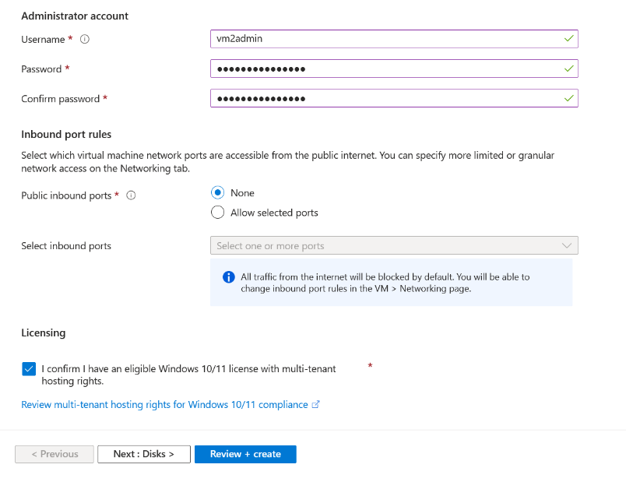
STEP 3: CREATE VM2

This VM will support no RDP or internet access
to do this I copied step 1 until I got to the
admin account and Inbound port rules.
I used “vm2admin” for the username and
“Virtualmachine2” as the password.
For public ports I selected “None” and in
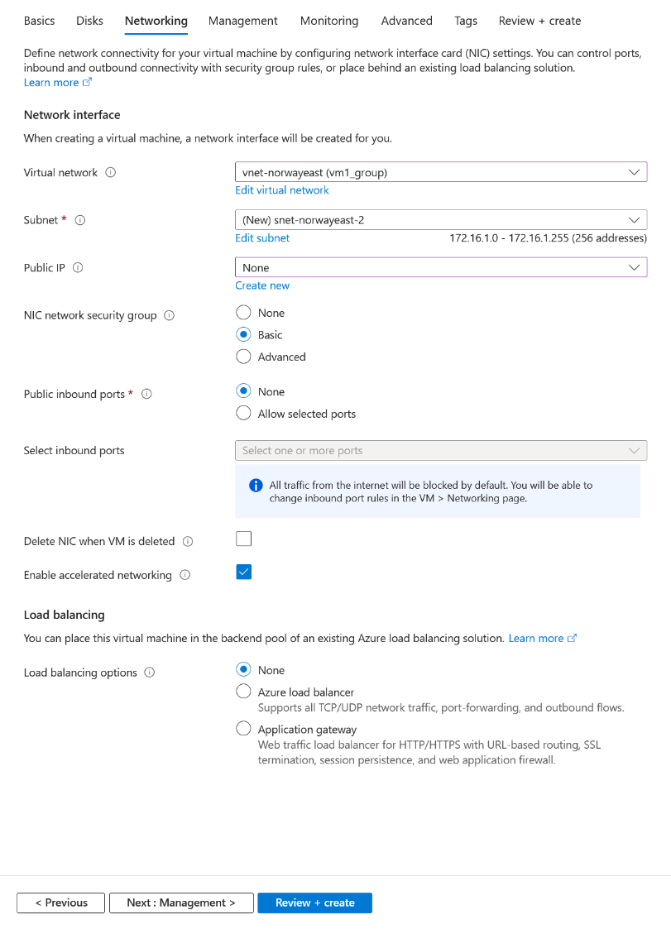
doing this it locks off the “select ports” drop
down menu.

Before I clicked create on the review page
I clicked on the networking tab above
As I wanted to configure this to be in
Connection to VM1. To do this I changed the
Virtual network to “vm1.group” as previously
Named, this makes sure that both VMs are
On the same VNet.

I select public IP to “None” and public
Inbound ports to “None” and left everything
Else default. I then created the VM2

Now I have 2 working VMs on the same VNet, VM1 contains its own public IP and VM2 has no IP but is connected to VM1 VNet.
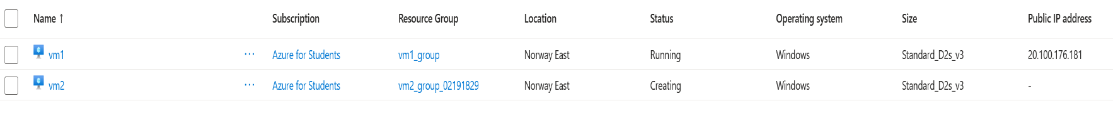

STEP 4: TESTING

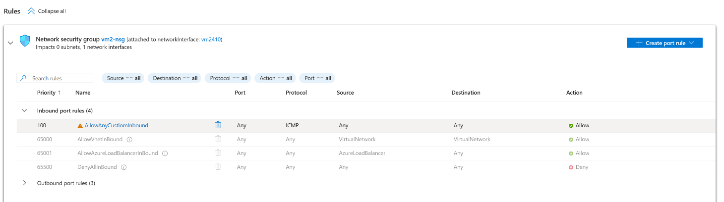
Before I can test if the VMs are connected I have to add some security rules to VM2 first. So I headed over to VM2s network settings and created both an inbound and outbound port rule called “AllowAnyCustomInbound” and “AllowAnyCustomOutbound” and I kept everything default other than selecting IMCPv4 for both port rules.

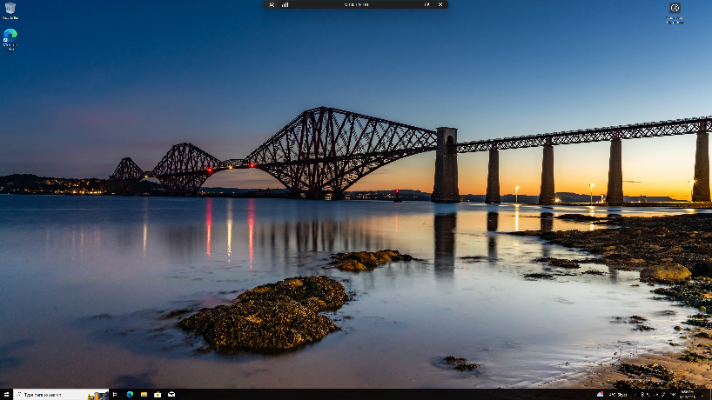
I finally booted up VM1 and got to the home
Page of windows, I proceeded to open
Powershell as I needed to change some
Firewall settings to allow me to test the
Connection between VMs.

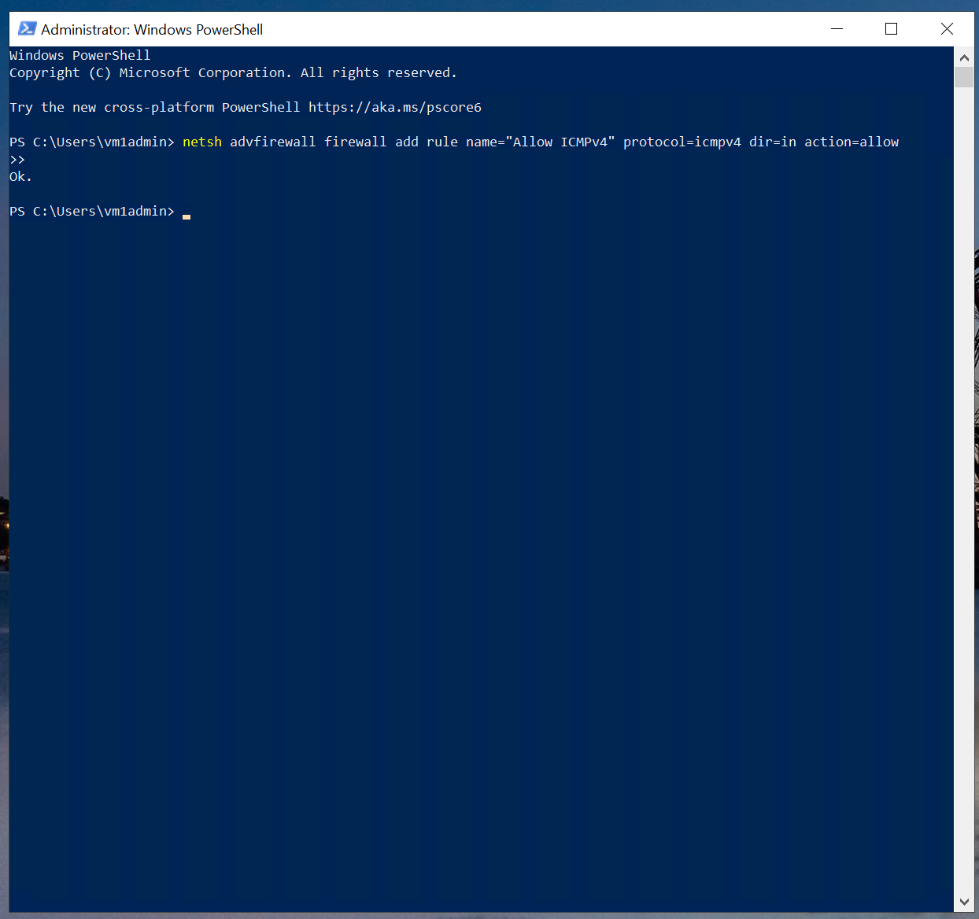

Once powershell is open I typed in
“netsh advfirewall firewall add rule
name="Allow ICMPv4" protocol=icmpv4
dir=in action=allow”
This prevents any blocks for inbound rules.

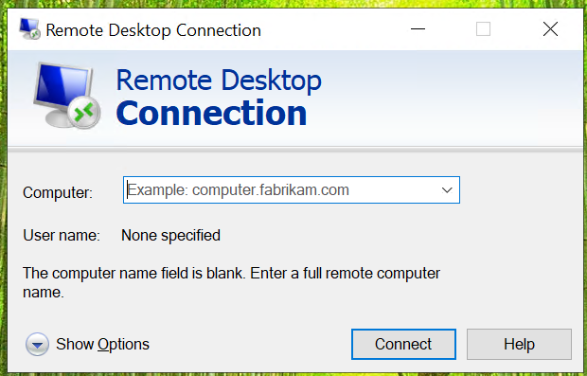
Now I am ready to test the connection
Between VMs. To do this I opened
“Remote desktop controller” on VM1
When it opens it asked me for a computer
Name, This is where I enter the private IP
Of VM2 which for me is “172.16.1.4”

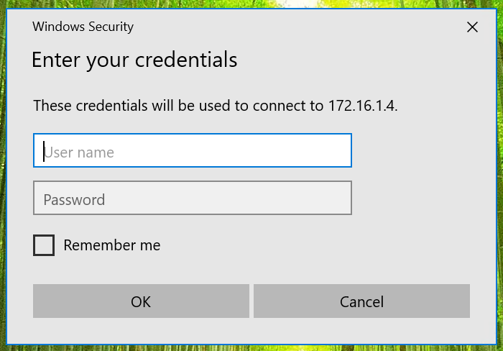

Once the VM2 has been found it asked me
For the VM2 credentials which I made
Earlier.

Once I have entered the credentials I enter VM2 Windows, from here I open Command prompt and typed “ipconfig” to show me VM2 details and then finally I typed my VM1s IP address “ping 172.16.0.4” and wait for a response. I managed to get a reply from VM1 showing me that they are connected and pinging to one another successfully.

